THE DRAWING(S) AND THE INFORMATION CONTAINED HEREIN ARE THE PROPERTY OF WOOJIN INDUSTRIAL SYSTEMS CO., LTD. THEY SHALL NOT BE DISCLOSED, REPRODUCED OR USED, IN ANY MANNER WITHOUT THE PRIOR WRITTEN CONSENT OF WOOJIN INDUSTRIAL SYSTEMS CO., LTD. |  | OPERATIONAL SCENARIO  FOR  DENVER RTD COMMUNICATIONS SYSTEM
DISTRIBUTION |  | R  E  V  I  S  I  O  N | 3 | May 7, 2013 |  | Contents Revised |  |  | D.B. LEE | D.S. JANG | B.J. JONE | E.K. LEE
 |  | R  E  V  I  S  I  O  N | 2 | Apr.13, 2012 |  | Added Contents |  |  | D.B. LEE | D.S. JANG | B.J. JONE | E.K. LEE
 |  | R  E  V  I  S  I  O  N | 1 | Nov. 30, 2011 |  | Added Contents |  |  | D.B. LEE | D.S. JANG | B.J. JONE | E.K. LEE
 |  | R  E  V  I  S  I  O  N | 0 | Oct. 14, 2011 |  | First Issued |  |  | D.B. LEE | D.S. JANG | B.J. JONE | E.K. LEE
 |  | R  E  V  I  S  I  O  N | No. | ISSUED  DATE |  | REVISION NOTE |  |  | DESIGNED | CHECKED | APPROVED | REVIEWED
 |  |  |  |  |  |  |  |  | ENGINEERING |  |  | PM
 |  | PM |  |  | REVIEWED |  | E.K. LEE |  | CUSTOMER :
 |  | ENGINEERING |  |  | APPROVED |  | B.J. JONE |  | HYUNDAI ROTEM COMPANY
 |  |  |  |  | CHECKED |  | D.S. JANG
 |  |  |  |  | DESIGNED |  | D.B. LEE |  | PROJECT :
 |  | ISSUED DATE |  |  | April 13, 2012 |  |  |  | DENVER RTD EAGLE P3  COMMUNICATION SYSTEM
 |  | ISSUED BY |  |  | R & D CENTER
 |  | PROJECT NO. |  |  | P2011-020
 |  | ORDER NO. |  |  | P110701149 |  |  |  | 
 |  | DOCUMENT NO. |  |  |  |  |  | REVISION
 |  | 423-317 |  |  |  |  |  | 3
TOTAL |  |  |  |  |  |  |  | 3
REVISION RECORD
Rev. No. | PAGE | Details |  | Date
Rev. No. | PAGE | FROM | TO | Date
0 |  | First Issued |  | October 14, 2011
1 | 19 | . | Added Cab-to-CPO Intercom Communications Diagram | November 30, 2011
1 | 20 | . | Added Cab-to-Cab Intercom Communications Diagram | November 30, 2011
2 | 5 | . | Added Booting Procedure | April 13, 2012
2 | 20 | . | Deleted DPO – CPO Communication | April 13, 2012
2 | All | . | Deleted all CPO related communications | April 13, 2012
2 | All | . | Revised all block diagrams | April 13, 2012
3 | 4 |  | Removed CPO | May 7, 2013
3 | 5 | . | Revised block diagram | May 7, 2013
3 | 7 |  | Removed CPO | May 7, 2013
3 | 8 |  | Revised contents | May 7, 2013
3 | 10 |  | Revised block diagram | May 7, 2013
3 | 11 |  | Revised block diagram | May 7, 2013
3 | 12 |  | Revised block diagram | May 7, 2013
Table of Contents
1. Booting Procedure. 5
2. Public Address System 6
3. Announcement 7
4. Record function. 8
5. PEI CALL 9
6. When DPO does not respond from PEI Call. 10
6.1 Leading CAB (When PEI Call occurred) 11
6.2 Non-Leading CAB (Operation scenario without CAB when PEI Call occurred) 12
7. Communication with DPO-PEI from the OCC 13
8. 3-way Communication between OCC-PEI from the DPO 15
9. PA Announcement from the OCC 16
10. Sending Real-time Text Display from the OCC 17
11. Transmitting the PEI voice to the OCC 18
12. DPO – OCC Communication Procedure: 19
13. DPO – DPO Communication. 20

Appendix A
Abbreviations
DPO | Driver PA Operation Box
PEI | Passenger Emergency Intercom
OCC | Operations Control Center
CSP | Cab Speaker

Booting Procedure.
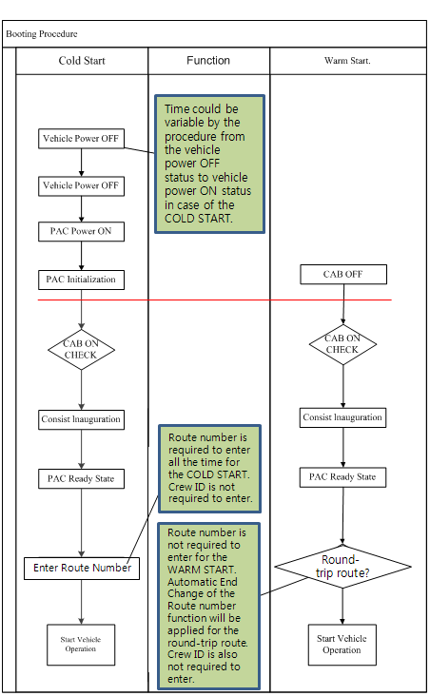
Please refer to Woojin SFD Document: 423-309 (3.2.1.1 System Initiation).

Public Address System
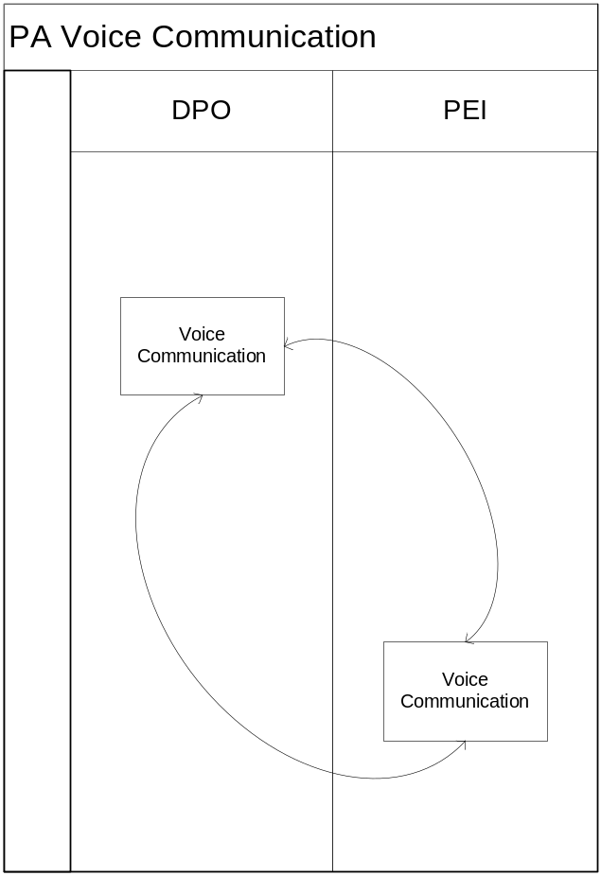

Voice communication should be available amongst PA systems, DPO-PEI. There should be no problem with operating device by using DC and by using a battery in case of emergency as well.

Announcement
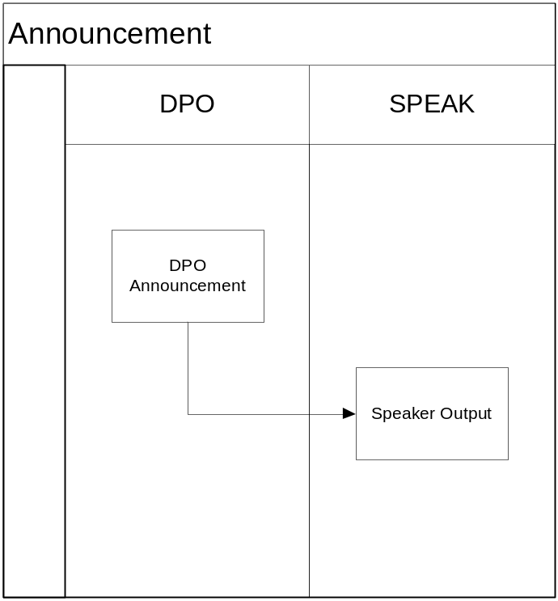

PA system is available for exterior communication via speakers by using DPO.
The announcement content enables automatic, manual and OCC direct communication.

Recording function.
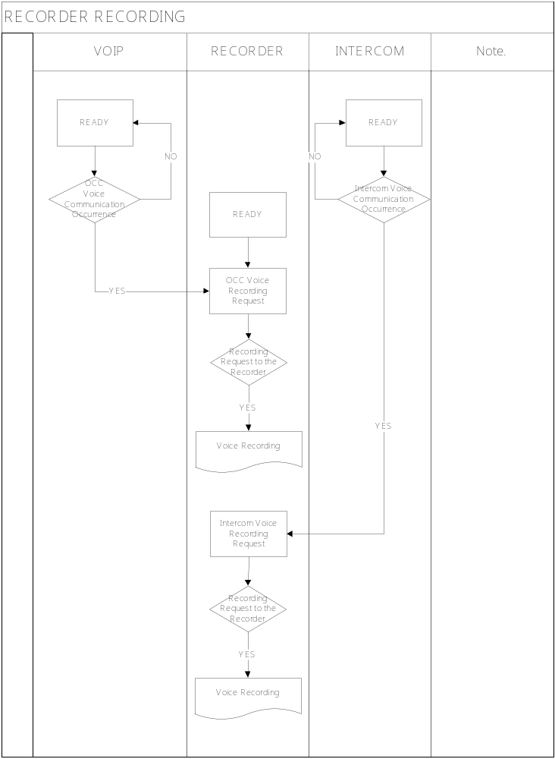
PA system records all kind of voice communication for 72 hours except for the automatic communication.
The enhancement of vehicle safety service is available as understanding exact causes for an emergency is possible by recording the communication amongst DPO – OCC / DPO – PEI / PEI – OCC devices.

PEI CALL.
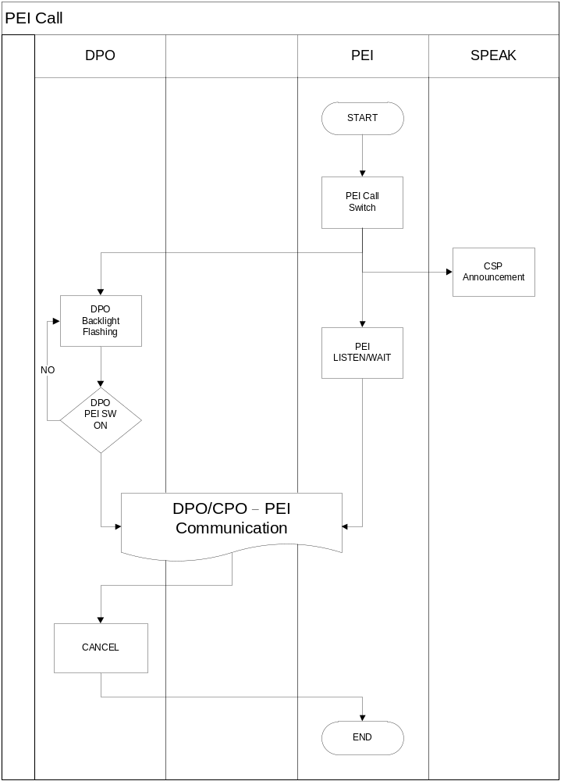
Passengers control the PEI communication button in case of emergency and the control button lamp is ON and Wait LED flashes.
The passenger’s calling location is announced via CSP speaker in the cab as the emergency button pressed.
PEI button lamp flashes on DPO and the communication waiting status is retained.
Driver can communicate with a passenger by pressing the DPO PEI button.
Press "CANCEL" button to end the communication when finished.

When DPO does not respond for PEI Call.
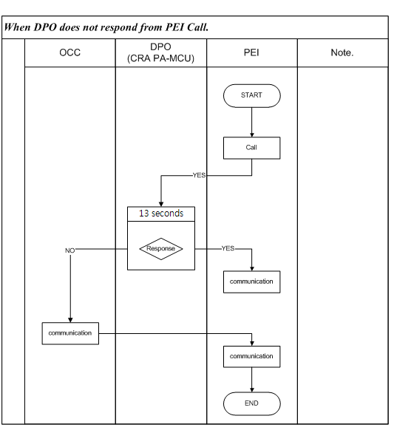
A driver must respond within 13 seconds if a passenger calls with PEI system in case of emergency.
It is automatically connected to OCC for an emergency if no response over 13 seconds.
OCC can communicate by using VOIP communication system and PEI calling is over when communication is ended.

Leading CAB (When PEI Call occurred)
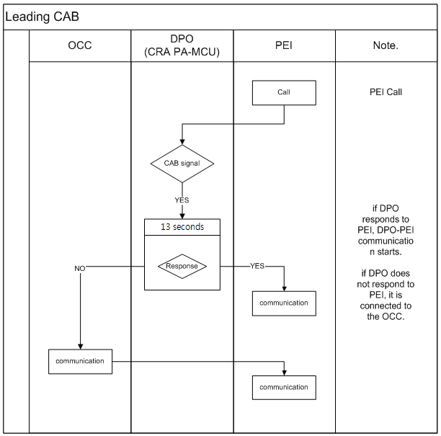

The engine room with "CAB" signal has priority as a passenger calls with PEI system in case of emergency.
It is connected to OCC if a driver does not respond for 13 seconds.

Non-Leading CAB (Operation scenario without CAB when PEI Call occurred)
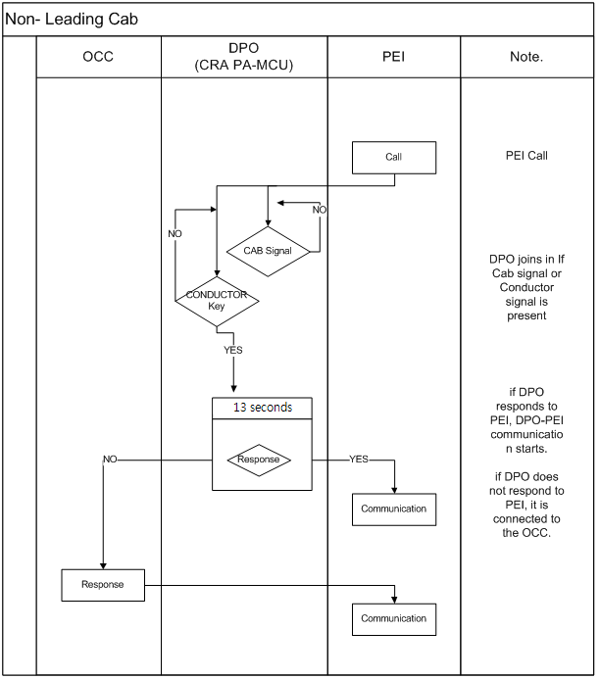
The engine room without "CAB" can communicate by using "CONDUCTOR" signal as a passenger calls with PEI system in case of emergency and the communication procedure is the same.

Communication with DPO-PEI from the OCC
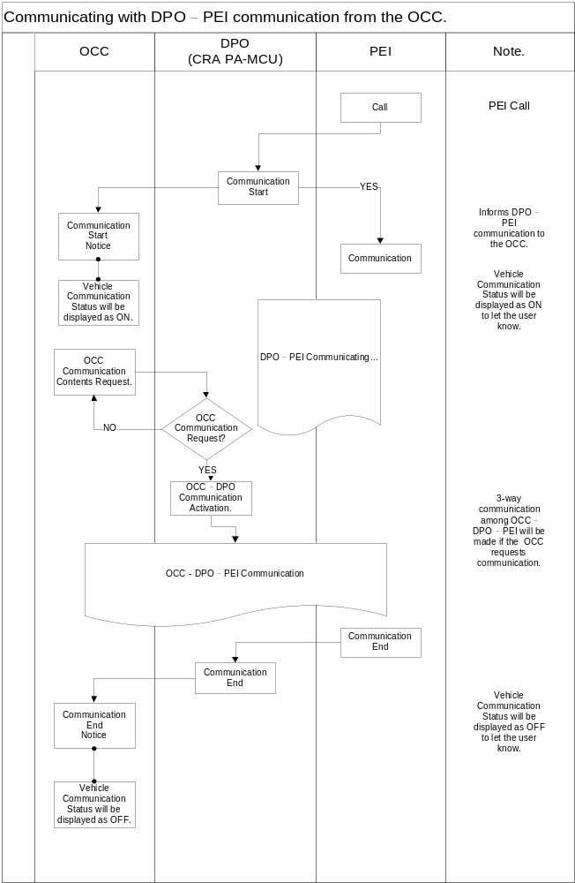
A driver should communicate with DPO system as a passenger calls with PEI system in case of emergency.
In this case, OCC can always be monitoring the communication status via Wimax when PEI-DPO communication.
During monitoring, OCC can require a 3rd party communication if needed and DPO revitalizes the function of a 3rd party communication by accepting a requirement.
PEI calling becomes "CANCEL" as a 3rd party communication is ended and the OCC monitoring is also finished.
※ The monitoring program should separately be installed in OCC.

3-way Communication between OCC-PEI from the DPO
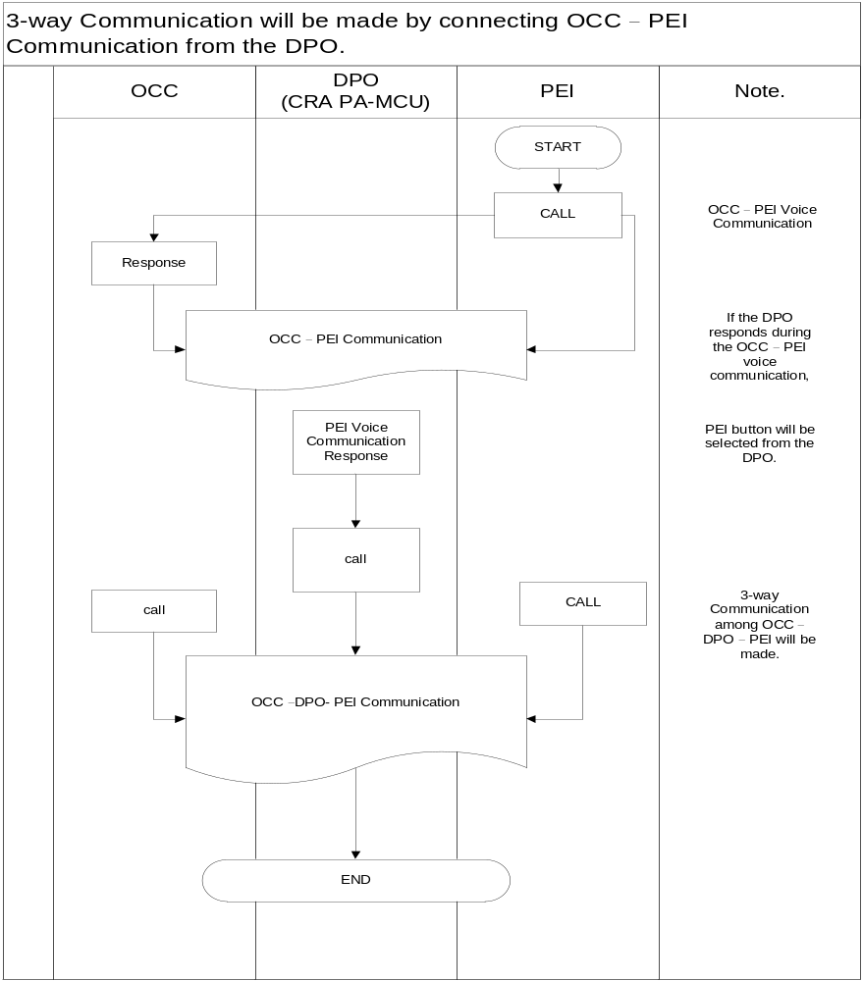
A driver recognizes PEI calling in the middle of the communication with OCC then press the PEI button to communicate if a driver does not respond as a passenger calls with PEI system in case of emergency.
In this case, OCC – DPO – PEI 3rd party communication is operated as OCC – PEI were already used.

PA Announcement from the OCC
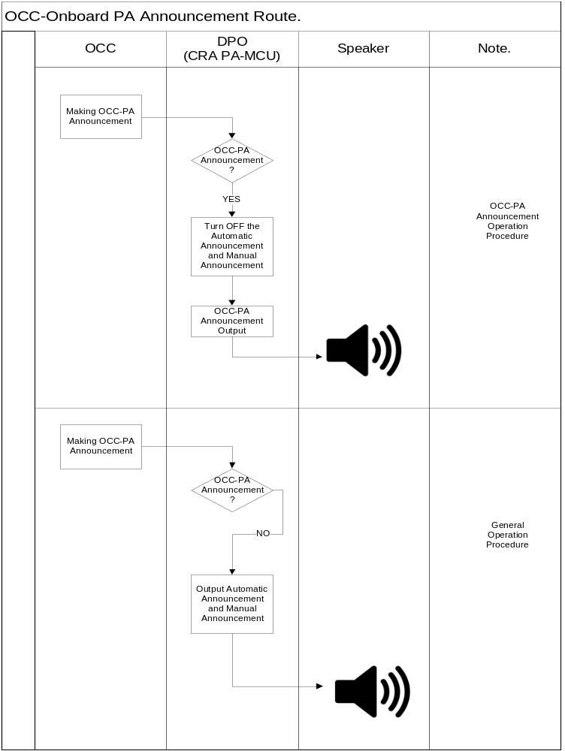
It is possible to execute manual communication to passenger In OCC when automatic operation.
In this case, automatic announcement is off and OCC manual announcement is on if DPO was automatically announcing.
OCC manual announcement is immediately on if DPO was not automatically announcing.
※ The monitoring program should separately be installed in OCC.

Sending Real-time Text Display from the OCC
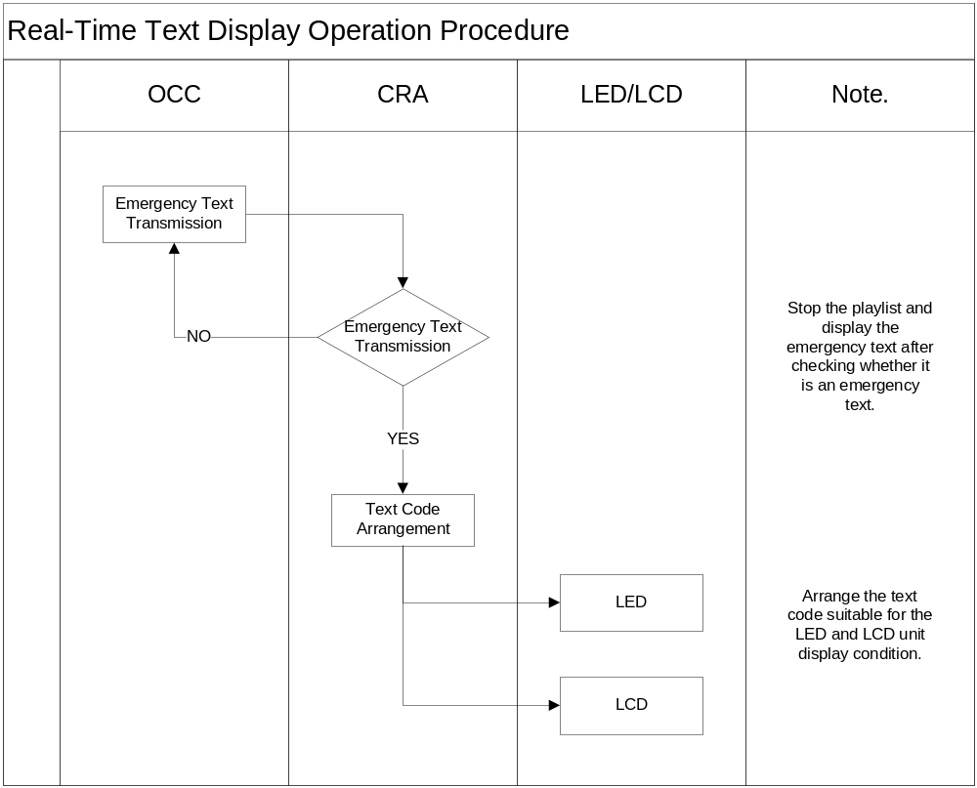

It is possible for vehicles to directly display letters on LED/LCD in OCC when automatic operation.
OCC receives the guide information and CRA clears the information being displayed and displays only letter information of the information on LED/LCD.
※ The monitoring program should separately be installed in OCC.

Transmitting the PEI voice to the OCC
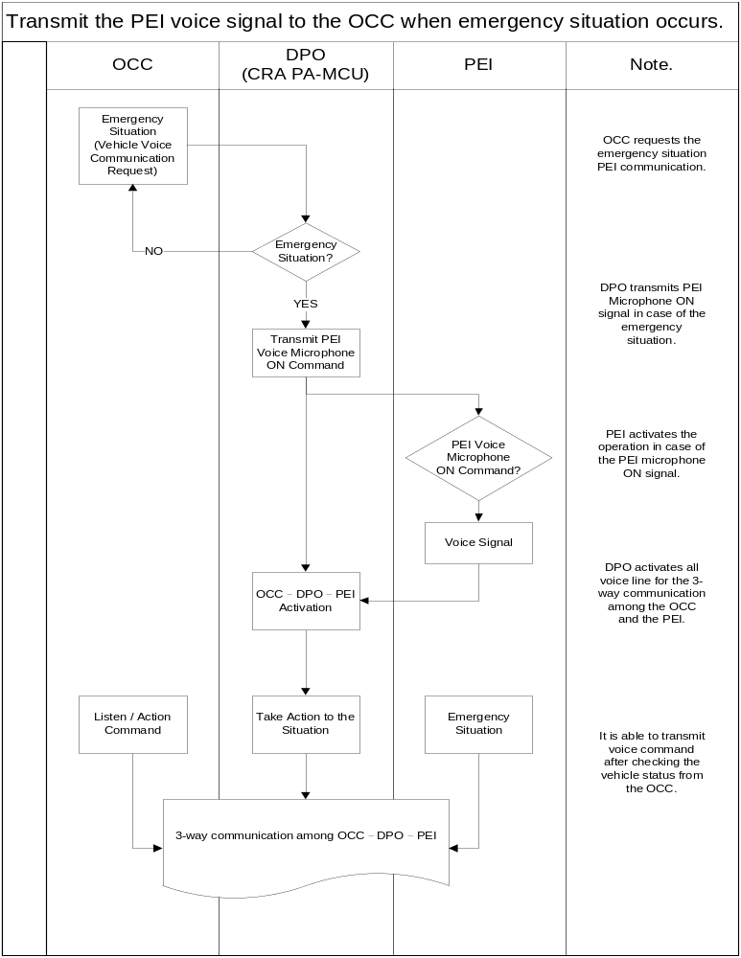
Turn PEI voice signals on if trying to monitor voice signals after monitoring an emergency situation by using CCTV in OCC.
Other voice data can be transmitted to OCC with VOIP system via DPO by turning PEI voice signals on.
※ The monitoring program should separately be installed in OCC.

DPO – OCC Communication Procedure:
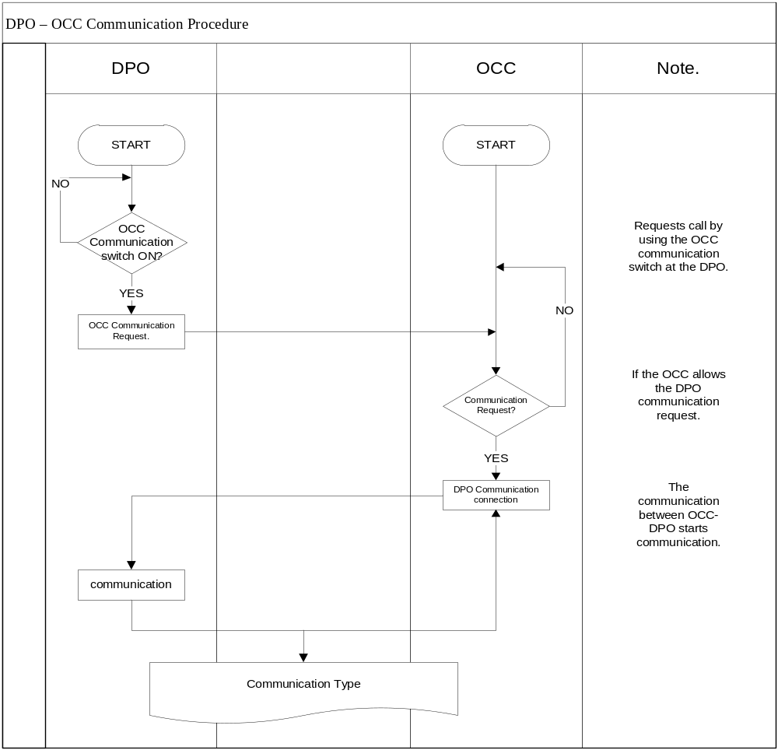
It is possible to communicate with DPO unit if a driver requires voice communication with OCC while driving.
DPO unit transmits voice signals to OCC via VOIP system if the OCC button of DPO system is on.
It is possible for OCC to have voice communication with each unit via the voice signal monitoring program received.
※ The monitoring program should separately be installed in OCC.

DPO – DPO Communication.
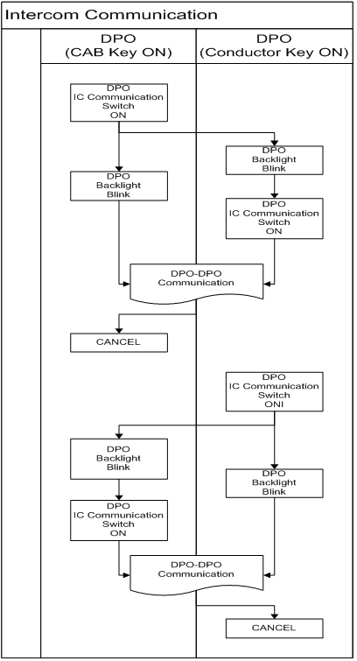

When IC switch is on in DPO(CAB KEY ON), DPO IC switch Back Light will be changed as flashing status and wait for DPO answer.
When call DPO IC switch is on, DPO IC Back Light will flash and reception DPO will let a driver recognize a call status.
The driver who checked a call status will switch on Conductor KEY, then turn on DPO IC switch.
When IC switch is on in Slave DPO, Master DPO IC switch Back Light will stop flashing, then communicate with DPO.

